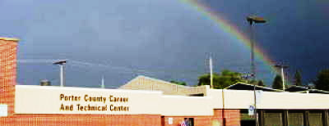

October 10, 2011 Career and Technical Education Volume 18, Issue 2

Our job includes making a profound difference
in the lives of our students!”

Award for Excellence Nominees Will be Presented to the Porter County Career and Technical Education District Advisory Council
Five Career and Technical Education students will be proposed as nominees for the Indiana Award for Excellence program. Over 1,000 students in our district are eligible for this honor and only ten will be selected out of the 60,000 eligible students across Indiana.

Our nominees follow:
Sarah Jackett, CHS, Video Media Productions - Sarah is a hardworking student, who has found her career passion in her Video/Media Productions class. She is active in her church, school, and community.
Rachel Santos, PHS, Video/Media Productions - Rachel is our key sideline reporter for the Video/Media Productions class. She is also the editor in chief of the PHS Pow Wow student newspaper. She is a great student and very active in her school and community.

Elizabeth Buth, BGHS, Health Occupations -
Elizabeth is an outstanding student at Boone Grove High School who is also a standout on the golf team. She participates in numerous clubs at her home high school including the Key Club.

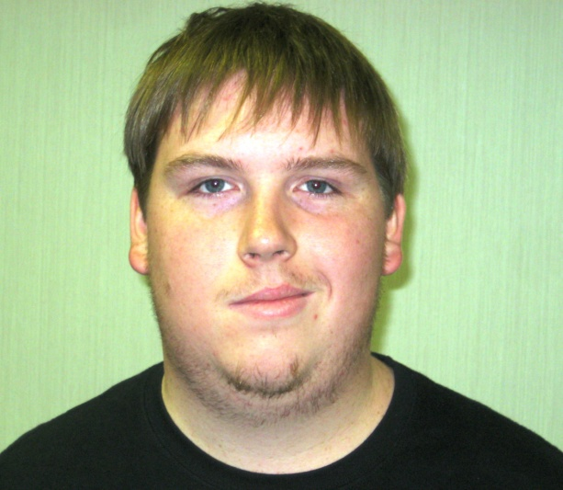

Zachary Moss (right), Portage High School, Industrial Mechanics -
Zachary is an outstanding student at Portage High School who is reliable, honest and respectful in his interactions with others. Zachary's strengths lie in his hard work and dependability. He enjoys playing the bass guitar and working on cars in his free time.

Jacob Lauritzen (left), Portage High School, Industrial Mechanics -
Jacob is an exceptional student at Portage High School who is involved with numerous activities at school and in the community. Jacob's strengths include math, science and computers. He enjoys building, modifying and competitively racing RC cars and working on real cars in his free time.

All five students will be presented to our Area Advisory Council for approval prior to forwarding their application packets to Indianapolis. We are proud of each of them; they are all winners with tremendous futures ahead of them.

Chicago Bull Star, Bob Love Visited the Career Center
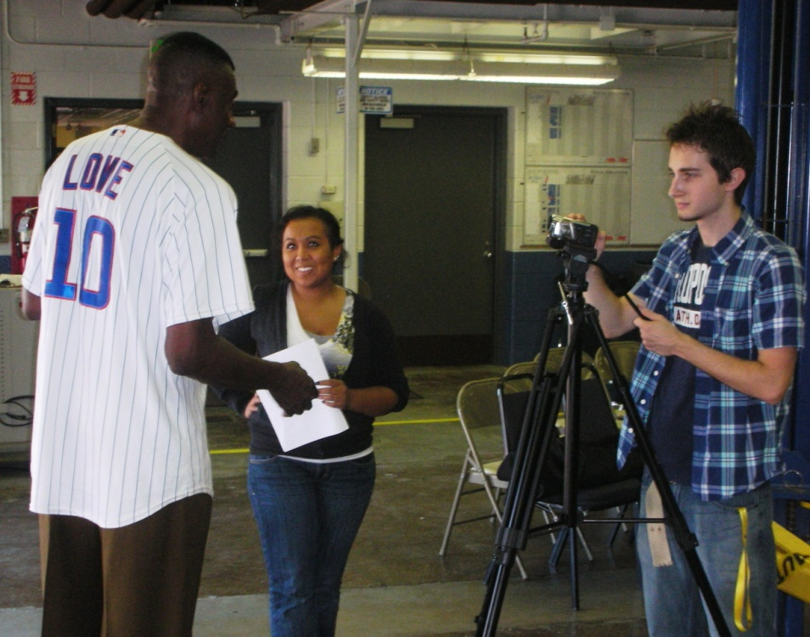
Videojournalist, Rachel Santos, interviewed Bob Love just after he addressed students at the Career Center. Bob’s message was to work hard, stay in school, and be careful about picking your friends. He said, “You will earn the average income of your four closest friends.” So, if you want to have a lot of money “pick your friends carefully”. Kyle Gilbert is seen operating the video camera for the interview.
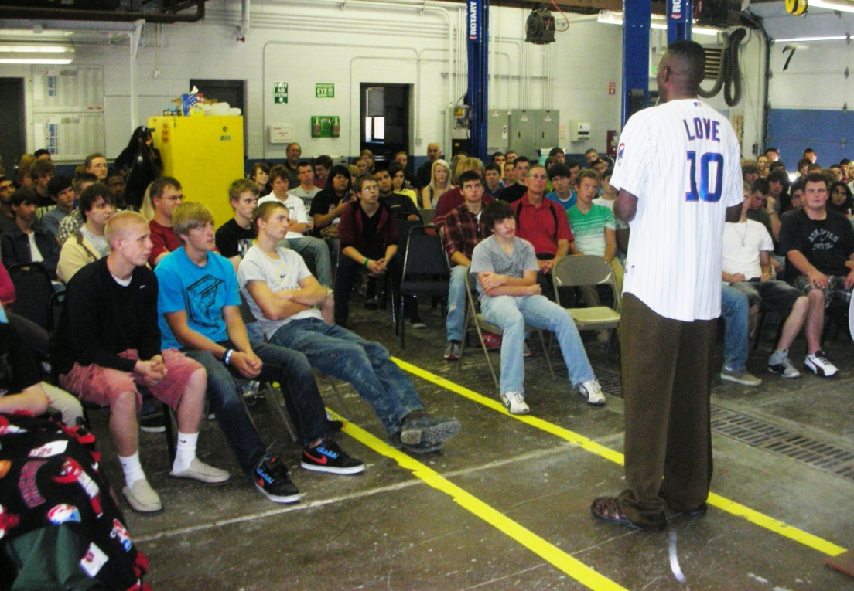
Mr. Love stayed to sign autographs, shirts, and basketballs, and to pose for photographs with numerous students.
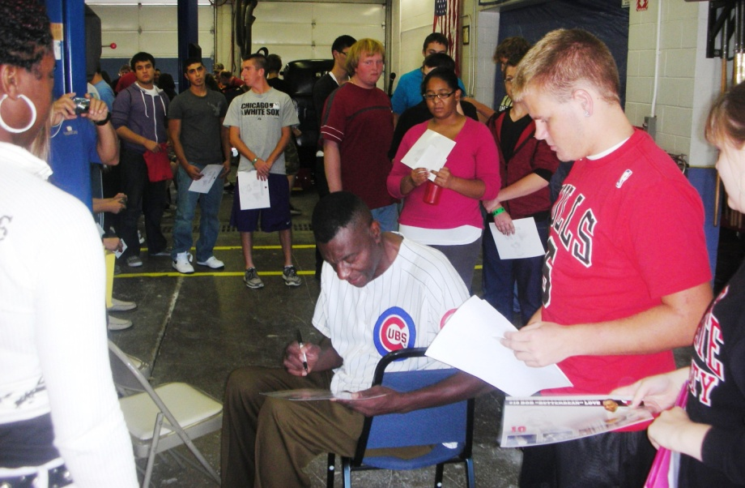
On top of being a famous basketball star, Bob Love is well known for overcoming a serious speech impediment after his playing days were over. His inspirational message of overcoming a disability was encouraging to all of us who battle through the daily ritual of life.

Recognition of a Hero
Jim Butz, Health Occupations,’08-09, CHS,
26 July 1990 – 28 Sept 2011
Spc. James A. Butz, 21, of Porter, was reportedly treating an injured soldier when their truck was hit by a roadside bomb. Spc. James A. Butz, 21, of Porter, died Wednesday in Helmand province. Jim is a 2009 graduate of Chesterton HS and a former Health Occupations student at the Career Center. He was a serious and sensitive young man, who was excited to become an EMT and later become an airborne medic. Jim was doing his medic job rushing to treat injured soldiers when an IED was exploded. He was serving in the 82nd Airborne Division based at Fort Bragg, N.C.

His awards include the Purple Heart, the Afghanistan Campaign Medal, the National Defense Service Medal, the Global War on Terrorism Service Medal, the Army Service Ribbon, a NATO Medal, a Combat Action Badge and a Parachutist Badge.

The Career Center is proud of Jim and his service, he died a hero to his country. He will be missed by many.

Source: http://www.nbcchicago.com/news/local/indiana-soldier-butz-killed-afghanistan-130912678.html#ixzz1Zag60lAu

Source: http://www.nbcchicago.com/news/local/indiana-soldier-butz-killed-afghanistan-130912678.html#ixzz1ZaftnCMP

Friday Night Lights, Camera, Action
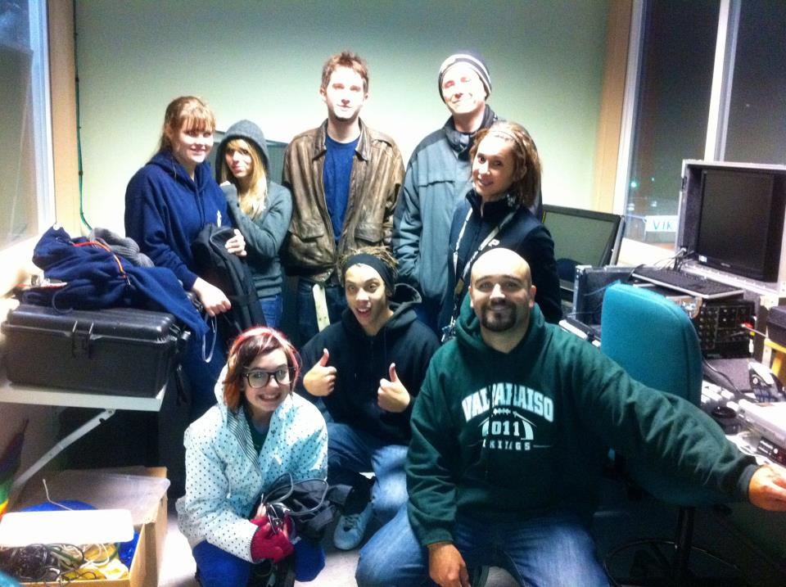
Above, Mr. Phelps and his students are shown who helped out on the production of the VHS homecoming football game.

Duneland Building Trades House
For Sale
858 Whitestone, Jackson Twp.
Property Details
- Price: $299,000
- Beds: 3 Bed
- Baths: 2.5 Bath
- House Size: 2,280 Sq Ft
- Lot Size: 1.65 Acres
- Year Built: 2011
Great News!!!
- Touchstone Energy rated our house at a 5 Star Plus, their highest energy efficiency rating! They have estimated total annual energy costs at $2585 (heating, cooling, appliances, lighting, and service).
- This rating comes with a Home Heating and Cooling Guarantee from REMC that annual heating costs will not exceed $752 and cooling costs will not exceed $117. Any excess over those amounts will be reimbursed to the homeowner at 50% of the overage. This guarantee is good for 12 months after the closing date.
Call Rick Hokansen of Boulder Bay Realty to request a showing, (219) 508- 3241.
Congratulations to the Chesterton High School Building Trades students and instructor, Mr. Jeff Larson, for this achievement.

Career Center Afternoon Building Trades Class

“Never let it be said that you can run faster than you can read or that you score more points per game than on your SAT. Get your education, stay in school, and make the right decisions.
Remember you will earn the equivalent of the average of your four best friends” – Bob “ButterBean” Love

Mrs. Gillespie’s Health Careers Class
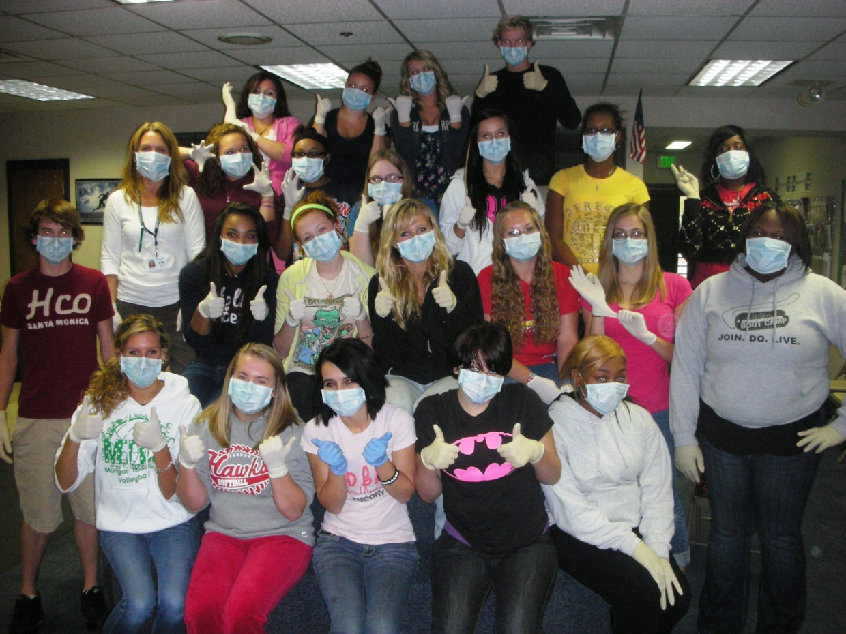
Target Donation
The Career Center received a $150 donation from Target® for customers who use the Target® REDcard® Charge card and designate the Career and Tech Center for the donation. Thanks to Target® and to those who support the Career Center.

Calendar
- October 8, 10 am to 2 pm, Winter Car Check, Free fluid, air, lights, and wipers inspection
- October 12, 8:15 pm, VEDC tour of building
- October 18, 6 pm, Career Center hosting the VCS Board of Education Meeting
- October 20, 3:30 pm, Area Advisory Committee Meeting, at the PCCTC
Students, Graduates, and Supporters are all invited to become a
Fan of the “Porter County Career and Tech Center” On Facebook

It is the policy of the Porter County Career and Technical Education Program to comply with all state and federal
regulations prohibiting discrimination on the basis or race, color, religion, sex, national origin, age or disability in
enrollment procedures or access to programs.

The Porter County Career and Tech Center and SELF School follow the cancellation/school delay decisions of the Valparaiso Community Schools. All other CTE sites follow the school closing decisions of the host school.

All commuting students should drive carefully and use their parent’s input and common sense when deciding if it is safe to drive to their CTE location.

In the event of severe or inclement weather, school may be delayed or canceled. Please use the following sources to track any weather related delays or cancellations:
- Go to the Valparaiso Community Schools homepage (http://www.valpo.k12.in.us). Select “School Closing Information” from the left-hand column and then register with VCS Alert to receive school closing/delay messages on your cell or home phone.
- Valpo or PortageLife: http://www.valpolife.com/ or http://www.portagelife.com/
- Cancellations.com (Students are encouraged to register for cancellation alerts via cell phone, home phone, and/or email for both his/her school and the school of his/her career and tech class.)
Our Newsletter
Porter County Career and Technical Education News is a newsletter for promoting the high achievement of our staff and students. Written contributions to the newsletter are always welcome. Most articles should be written in 100 words or less. Please fax (531-3173), call (531-3170), or email (jgroth@mail.valpo.k12.in.us) with news to be published about you and your students.

Porter County Career and Technical Education

www.pccte.org

